Claremont Park Electrical Box Mural

I was asked by Althea Wagman-Bolster to paint a mural on the electrical box on the Southwest Corridor Park near Claremont Park.

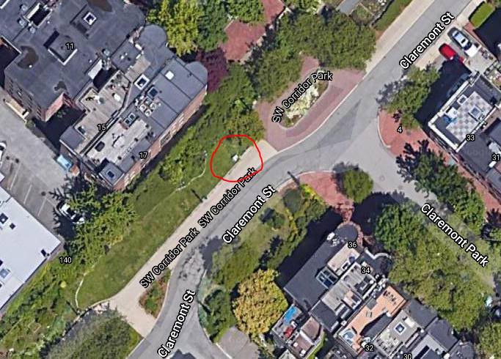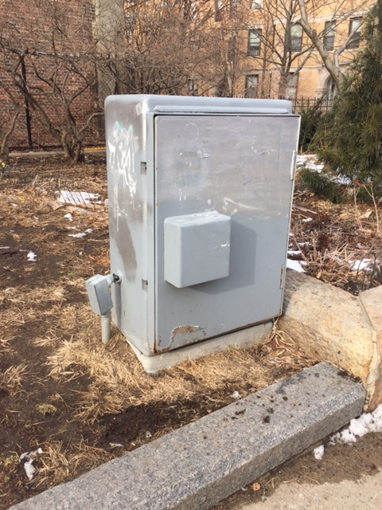

The concept I have for the mural is to paint the electrical box to look like two wooden beehives, something like these pictured here, with the protruding part of the electrical box looking like a draw pulled out showing a bit of honeycomb on top. There would be larger than life bees on the beehives, and wild flowers growing from the bottom. The electrical box would first be scraped and primed and exterior house paint would be used to do the painting.

